
23rd Annual
CALENDAR POSTER CONTEST

PRIZES

GRAND PRIZE:
- $100 for you!
- Your poster on the cover of our 2027 Calendar.
- Up to $1,000 grant for your school.

12 MORE WINNING POSTERS:

- Your poster printed in the 2027 calendar and prizes.

sponsored by the Marshall County Landfill
RULES

ELIGIBILITY: This contest is open to students in Grades K-5 in Marshall County.
POSTER GUIDELINES:
- THEME: Recycling Begins at Home.
- Use the front of this paper to draw a horizontal picture
- Show off your artistic skills! Make it colorful.
ENTRY FORM: Fill out the form below so we can get in touch. Be sure to get a Parent/Guardian signature.
DEADLINE: Entries must be returned to the school by Friday, October 2nd for consideration.


Winning entries will be announced by Friday October 16th, calendars and prizes will be distributed to each participant on Monday, November 16th in a celebration @ Marshalltown Community College @ 6pm.
For more information about this or other outreach programs visit www.marshallcountylandfill.org or email Jenn@marshallcountylandfill.org

Don’t forget, posters are due November 10!

ENTRY FORM
STUDENT’S FULL NAME:__________________________________________________ GRADE:_____________________
SCHOOL:________________________________________ TEACHER:_________________________________________
PARENT/GUARDIAN:_____________________________________________________________
MAILING ADDRESS:______________________________________________________________
EMAIL:______________________________________________________________
PHONE:_______________________________________________________________________

I authorize release of ______________________________________’s name, artwork and photo for publication
child’s name
by Marshall Co. Landfill in promotion of this program. ___________________________________________________
parent/guardian signature date

SUBMIT ENTRIES TO: Your school or Marshall Co. Landfill PO Box 217 Marshalltown, Ia. 50158






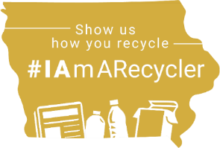

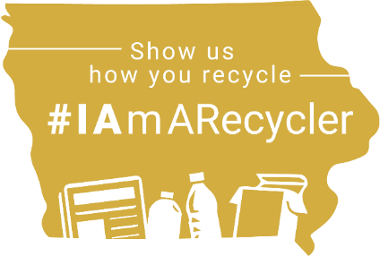
Recycling Begins at Home.

22nd Annual POSTER CONTEST

